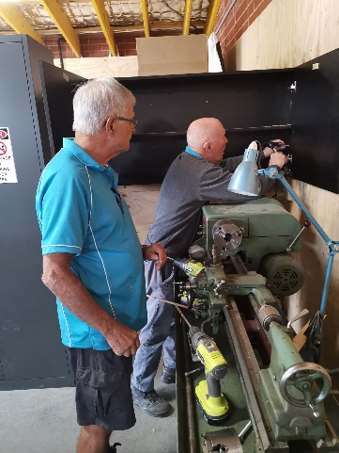I thought I should get this out to you today as there isn’t much of April left.

We have been a little quiet in the last two weeks as we work in the background trying to generate some projects

Norm

I received an email yesterday letting me  know that Norm and Andrea have arrived in Cairns safely after travelling 3377 kms there by car through Charleville and Longreach. The enormous rains up there have delayed the pouring of the footings for their house. In the meantime they are comfortably accommodated.

My Role

With Norm leaving we have tried to keep some stability in the Shed management. The committee voted me in as President to fill the extraordinary vacancy until the AGM in July. Currently I am prepared to fill the roles of President/ Secretary/ Workshop Coordinator but as from the AGM we will need at least two members to cover these roles. (Our constitution states that we must have a separate person for President and a separate person for Secretary, other than in our current interim situation).  Eventually I will need some time to work on the growing list of jobs at home.

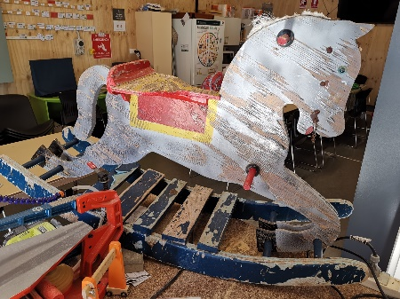One of the good things about our Shed is that we have a group of nine supervisors who take on various jobs as they arise, which shares the work around. Please think about stepping up or encouraging another member to do so.

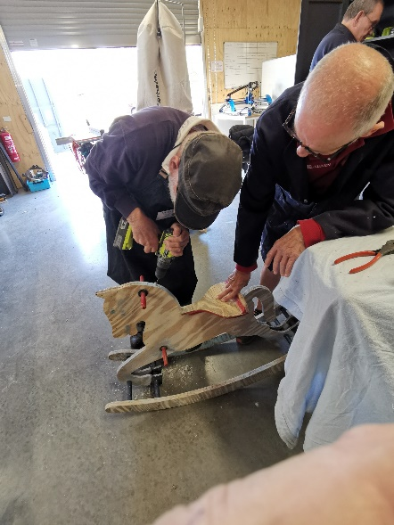

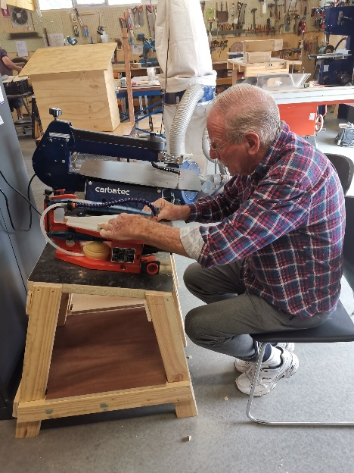Personal and Shed Projects.

Members are encouraged to bring along their own projects to work on as well as assist in Shed Projects. Last year and early this year we spent most of our time producing nesting boxes and street libraries but these two major projects have run their course for now. We are in negotiation with a community group to make an outdoor bench seat and we are looking at making some wicking garden beds. We have just accepted a job to make some ramps and stands for a doggie day care. It takes time to get these  projects running with the need to source materials, decide on design and negotiate price.

We would like to encourage the making of smaller projects such as wooden toys (we have a good range of plans and templates available in the Shed), children’s furniture, cheese boards, pot plant stands etc.

If you have some ideas on what we can make to sell or use at home please let us know.

Shed projects may only run on certain days depending on the days the project ‘leader’ is in the Shed. Having smaller projects that an individual or a couple of shedders are working on means that there is something you can work on any time you come to the shed because you aren’t relying on others to explain the next step.

Types of Projects

Any member can work on any project of their own and use our equipment (and wisdom!) We have some timber available that may suit but there will be a small charge for this if the project is for you. If you make a project for the Shed to sell, then no charge. We remind you that we encourage members to make things for themselves and family but it is not in the spirit of the Shed to make things using our equipment so you can sell them as a small business or similar.

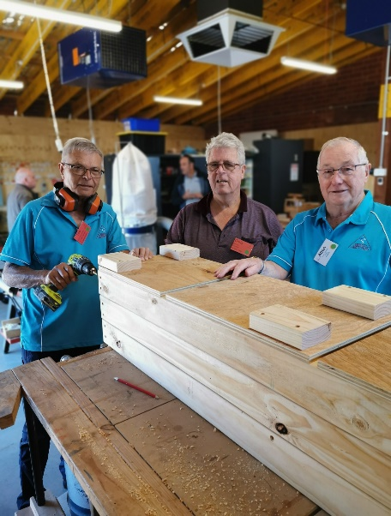Project completed in a day

This week Alan Wilson brought along some timber to cut to size so he could make a planter box. He envisaged that this would be a project that would keep him going for the next couple of weeks or so. There were some other Shedders who had nothing better to do than help him with this project. By the end of the morning session, not only had the timber been cut but he had a completed planter box to take home. Alan will have scored some brownie points at home and we believe he will be in the good books for at least the next two weeks.

CNC Router

The CNC has arrived and is now mounted on its table. Next Thursday Murraylands Shedders are making a visit to us to help us do our first carve. A number of members have asked what can be produced using the CNC. I have attached a couple of sheets showing some examples. There are literally hundreds of ideas. We will have the capability to either carve using a router of burn using a Laser.

Bunnings Barbecue

The roster is on the table for the next BBQ. Please consider taking your turn. If everybody helps out you only need to do one shift, morning or afternoon, for the year. The thought of doing it is a lot worse thnt actually doing it. It is good fun and a good socialising time. Please put your name down. Good money earner which keeps your membership fees low.

Shed Socialising

Earlier in the year we let you know that we were not running a separate lifestyle program but instead were encouraging less formal socialising in the Shed. It is pleasing to see this happening with many of the coffee/ tea breaks being extended as members sit and chat.

We now have some members who come to the shed simply to enjoy socialising in the kitchen area. You may not be interested in our Workshop Projects but we encourage all members to come and have a chat and drink (and a bikkie) which starts around 10am Mon to Thurs.

You will be amazed how much information you can pick up amongst the b---sh-t.

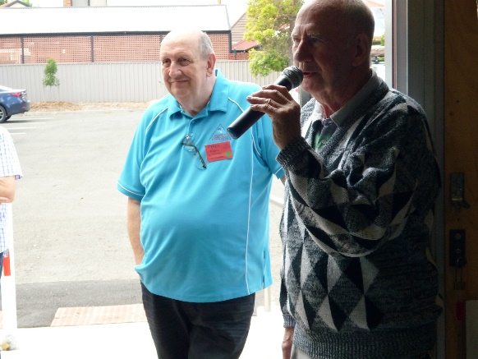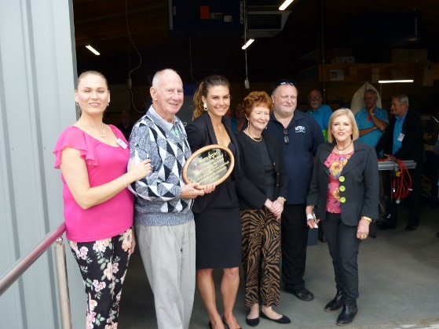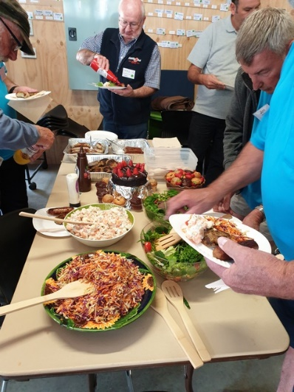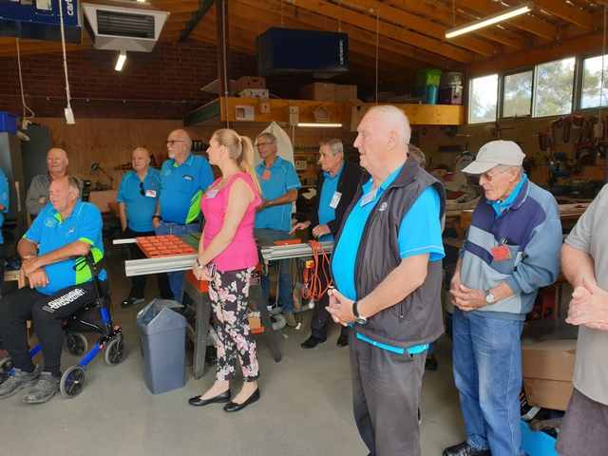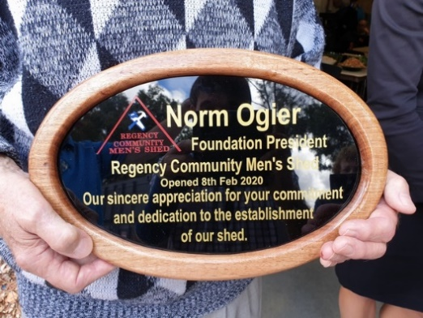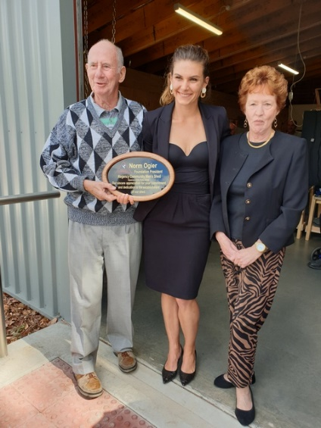

**Peter Rawlins**

*President/Secretary/Workshop Coordinator*

Regency Community Men’s Shed Inc

Mobile: 0400115249

540 Regency Road, Enfield SA 5085

Web: [www.regencycommunitymensshed.com](http://www.regencycommunitymensshed.com/)

Email: [regencycommunitymensshed@gmail.com](mailto:regencycommunitymensshed@gmail.com)